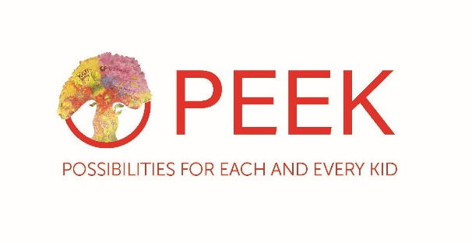

Position: | Community Arts Intern
Hours: | 20hrs per week  Flexible between 8am – 8pm  Evening & weekend work may be required
Salary: | £9.50 p/h
Responsible to: | Community Arts Coordinator
Responsible for: | N/A

CORE FUNCTION:
The Community Arts Intern will work with the PEEK Create Team to delivery high quality Creative Arts sessions across communities in the East End of Glasgow in preparation for PEEK’s “East End Arts Festival 2021.”

DUTIES:
Delivery
- Support the planning and delivery of a range of creative learning activities and events for children and families, including:
- Children’s Community Theatre Programme
- Children’s Community Visual Arts Programme
- Family Community Visual Arts Programme
- Early Years “Play Café” Programme
- Children’s School Visual Arts Programme

- Support the planning and delivery of PEEKs “East End Summer Arts Festival 2021.”
- Support Children and Young People to achieve Arts Award.
- Make sure that safety procedures are followed conforming to the organisations Child Protection, Health & Safety, and other relevant policies.
- Complete any appropriate reports e.g. accident / incident forms, niggle forms, Child Protection forms.
- Supervise children/young people at all times promoting positive behaviour.
- Plan and Implement activities suitable to the age, physical, emotional and social ability of all the children participating.

- Develop positive relationships with children, young people and their families.

- Adhere to and work within all the policies of PEEK, such as child protection policy, protection of vulnerable adults, confidentiality and data protection policies, and the policies contained within the employee handbook.

- Work as part of the PEEK team in order to develop and provide appropriate programmes, services, internal referral processes and systems to achieve positive outcomes in line with the aims of PEEK for children, young people and families accessing services provided by PEEK including providing cover for other team members or services.

Communications & Partnership Work
- Be proactive in using Social media (Facebook, Instagram and Twitter) to capture comments and feedback from children, young people and other stakeholders.

- To work in line with, and to support the delivery of, the vision, mission, values and social aims of PEEK and to be a champion for PEEK at all times.

- Contribute to joint working and promote effective and positive partnership working between PEEK and other relevant stakeholders, agencies, organisations and individuals. This will include the sharing of skills, knowledge and resources were appropriate. This may also include delivering presentations internal and external.

Monitoring & Evaluation incl. Operational Planning
- Support the development and maintenance of an operational plan and activity plan for PEEK Create reviewing it on a monthly and quarterly basis reporting on achievement of targets and outcomes to the Community Arts Coordinator, Head of Operations and CEO.

- Undertake and complete an Arts Award portfolio at Bronze, Silver or Gold level.

- Ensure all work including programmes, training, interventions and support to individuals, groups and organisations are effectively recorded and monitored in order to facilitate planning, achieve outcomes and contribute to performance management on an individual, project and organisational basis using the information to produce high quality statistics and reports as required.

- Continue to develop and implement monitoring and evaluation procedures:
- Keep accurate records including registers and contact/consent forms
- Input and maintain the monitoring and evaluation database(s) on a daily basis
- Complete session evaluations including observations and participant comments/feedback
- Contribute to wider quarterly operational and evaluation reports including constructing case studies for internal and external use such as Funders and PEEK board of directors
- Be pro-active in seeking out feedback from participants ensuring children’s voice is central into shaping the delivery of the sessions and overall play programme
- Carry out and collate visuals of children and families experiencing Create through multi media
- Carry out and collate regular feedback from parents/partners and others through visual evaluation techniques

- Work in collaboration with external stakeholders and researchers to support the evaluation of PEEK and Create.

Finance & Fundraising
- Work within the Project/Programme Budgets:
- Order and source materials as per direction from Community Arts Coordinator/Head of Operations/Head of People and Programmes/CEO
- Support and champion PEEKs fundraising campaigns i.e. annual fundraising events

Expectations
- The Community Arts Intern will be expected to undertake an Arts Award Qualification at either Bronze/Silver/Gold level.
- Participate in support and supervision, attend internal team meetings, including those of the Board and its Sub Groups as requested and attend any training identified as relevant.
- Ensure that confidentiality is maintained at all times working within the policies of the organisation.
- The Community Arts Intern is expected to maintain an up to date knowledge of all relevant standards, legislation, policies and good practice. They will be expected to undertake such appropriate training as is necessary to facilitate this.
- Carry out any duties as may be reasonably requested by the Community Arts Coordinator or SMT.

The job description is a broad picture of the post at the date of preparation. It is not an exhaustive list of all possible duties and it is recognised that jobs change and evolve over time due to the nature of the communities PEEK serve.

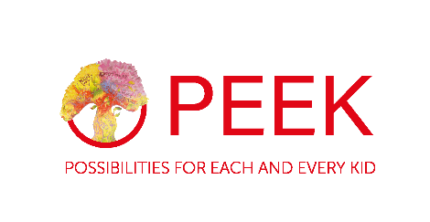

Community Arts Intern Specification

Essential Criteria
- Experience working or volunteering directly with children, young people and/or families in either/both a school or community setting
- Be between the ages of 16-21 and not in Full Time Education
- Be interested in a future career in the Arts or Community based work
- Be willing to undertake and submit a Bronze/Silver/Gold Arts Award

Essential skills, knowledge and abilities

- Able to provide support to people in a way that promotes their involvement, independence, resilience and achieves positive changes in their lives
- Able to communicate effectively with a diverse range of people and audiences at different levels of understanding and ability
- Able to work successfully on your own and as part of a number of teams and partnerships both internally and externally
- Able to organise and prioritise own workload effectively to meet job and project objectives
- Ability to build positive and healthy relationships with children, families and colleagues
- Willingness to learn and adapt in an ever-changing environment

Desirable but not essential – skills, knowledge and abilities

- A sound knowledge and understanding of the challenges faced by children, young people and families within the communities we serve
- Able to use Microsoft Office packages such as Microsoft Word, Excel and Office 365
- Knowledge of social media channels and the benefits of using them to evidence impact
- Valid Food Hygiene Certificate
- Valid Health & Safety in the workplace Certificate
- Valid First Aid Certificate
- Driving license and access to own vehicle

