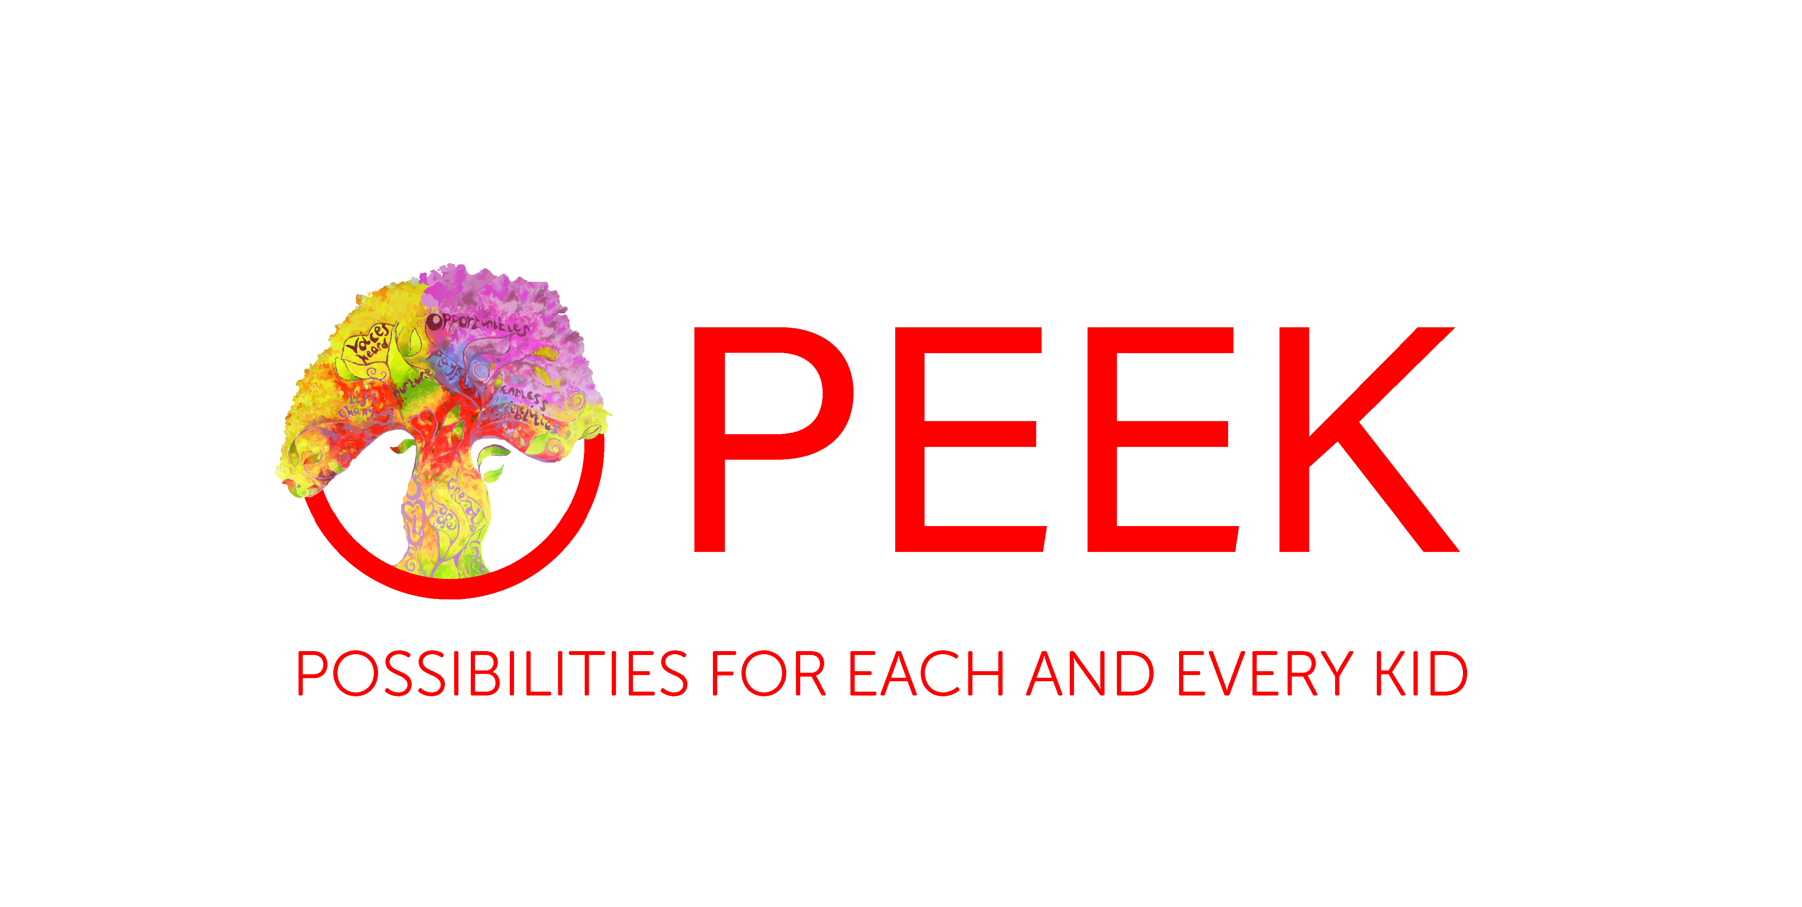

Performance Arts Coordinator Specification

Essential

- Experience in developing and facilitating child and young person led Arts projects, with a particular focus on theatre arts
- The ability to listen to the children, young people and communities’ needs and wants
throughout designing, planning and delivering programmes
- Experience in collaborating with a wide range of people; from the children and young people and their families to artists, other team members and partners
- The ability to be organised and adaptable in your approach
- Demonstrate energy in all that you do and display a ‘can-do’ attitude,
- Be open to change and new ways of working,
- The ability to problem solve and make decisions
- Awareness of Child Protection guidelines and relevant legislation
- Awareness of risk assessment and risk benefit
- Experience and understanding of working in a fast moving environment
- Experience in monitoring and evaluation
- An understanding of children’s emotional health and well being
- Digital/Media Skills

Highly Desirable

- Experience in Coordinating projects and events
- Experience in supervising/line managing staff
- Be in possession of a related Certificate, Diploma or Degree
- Have knowledge or experience of delivering Arts Award at Discover/Explore/Bronze level
- An understanding of the and experience of using a Community Development Approach
- Be in possession of a driving license

Desirable and/or Helpful
- Ideally have knowledge of basic first aid [training can be arranged]
- Experience of working in partnership with a number of stakeholders including parents/carers and schools

